Supplementary information for
Changes in ground beetle assemblages (Coleoptera, Carabidae) along an industrial pollution gradient in the Southern Urals
E.A. Belskaya, M.P. Zolotarev, A.N. Sozontov

Table S1. The number of adult individuals and larvae (in brackets) of ground beetles captured during both sampling rounds at different distances from the KCS (2009)
Species | Distance to smelter (km) and direction*
Species | 32 N | 27 S | 26 S | 18 N | 12 S | 11 N | 9 S | 5 N | 4 S | 1 E
Agonum fuliginosum | 0 | 0 | 3 | 0 | 0 | 0 | 0 | 0 | 0 | 0
Agonum gracilipes | 0 | 0 | 0 | 0 | 0 | 0 | 0 | 0 | 0 | 0
Amara brunnea | 14 (2) | 1 | 0 | 1 | 0 | 0 | 1 | 33 | 95 (3) | 0
Amara communis | 17 | 12 | 7 | 5 | 8 | 4 | 9 | 9 | 16 | 0
Amara eurynota | 1 | 0 | 0 | 1 | 0 | 0 | 0 | 0 | 0 | 0
Amara familiaris | 0 | 0 | 0 | 0 | 0 | 0 | 0 | 1 | 0 | 0
Amara majuscula | 0 | 0 | 0 | 0 | 0 | 0 | 0 | 0 | 0 | 0
Amara municipalis | 1 | 0 | 0 | 0 | 0 | 0 | 0 | 0 | 0 | 0
Amara ovata | 0 | 1 | 0 | 0 | 0 | 0 | 0 | 0 | 0 | 0
Amara praetermissa | 2 (2) | 0 | 0 | 0 | 0 | 0 | 0 | 1 | 1 | 0
Amara sp. | 0 (2) | 0 | 0 | 0 (2) | 0 | 0 (1) | 0 (1) | 0 (2) | 0 (1) | 0
Badister bullatus | 10 | 0 | 9 | 5 | 3 | 1 | 0 | 0 | 0 | 0
Badister lacertosus | 1 | 8 | 19 | 4 | 3 | 9 | 8 | 0 | 0 | 0
Bembidion lampros | 0 | 0 | 0 | 0 | 0 | 0 | 0 | 0 | 0 | 0
Bembidion quadrimaculatum | 0 | 0 | 0 | 0 | 0 | 0 | 0 | 0 | 0 | 0
Calathus erratus | 0 | 0 | 0 | 0 | 0 | 0 | 0 | 0 | 0 | 0
Calathus melanocephalus | 0 | 0 | 0 | 0 | 1 | 0 | 0 | 0 | 0 | 0
Calathus micropterus | 6 | 1 | 3 | 1 | 22 | 0 | 1 | 0 | 32 | 0
Calosoma sycophanta | 0 | 0 | 0 | 0 | 0 | 0 | 0 | 0 | 0 | 0
Carabus aeruginosus | 0 | 0 | 0 | 0 | 0 | 0 | 2 | 0 | 0 | 0
Carabus arcensis | 0 | 0 | 0 | 0 | 7 | 2 | 4 | 0 | 0 | 0
Carabus cancellatus | 2 | 0 | 2 | 3 | 71 | 17 | 19 | 0 | 0 | 0
Carabus convexus | 0 | 0 | 4 | 2 | 0 | 0 | 0 | 0 | 0 | 0
Carabus glabratus | 0 | 0 (1) | 4 (2) | 0 | 0 | 0 | 0 | 0 | 0 | 0
Carabus granulatus | 33 | 65 (1) | 79 (1) | 61 | 12 | 80 | 6 (2) | 0 | 0 | 0
Carabus henningi | 0 | 0 | 6 | 0 | 0 | 0 | 0 | 0 | 0 | 0
Carabus schoenherri | 0 | 3 | 3 | 4 | 0 | 2 | 0 | 0 | 0 | 0
Carabus stscheglowi | 0 | 0 | 0 | 0 | 1 | 0 | 4 | 0 | 0 | 0

Continuation of the table S1
Cicindela sylvatica | 0 | 0 | 0 | 0 | 0 | 0 | 0 | 0 | 1 | 0
Curtonotus aulicus | 0 (1) | 0 | 0 (1) | 0 | 1 | 0 | 0 | 0 | 0 | 0
Curtonotus gebleri | 0 | 1 | 5 | 0 | 0 | 1 | 0 | 0 | 0 | 0
Cychrus caraboides | 0 | 1 | 1 | 0 | 0 | 0 | 0 | 0 | 0 | 0
Harpalus affinis | 0 | 0 | 0 | 0 | 0 | 0 | 0 | 0 | 0 | 0
Harpalus griseus | 1 | 0 | 0 | 0 | 0 | 0 | 0 | 0 | 0 | 0
Harpalus laevipes | 0 | 0 | 10 | 2 | 2 | 0 | 2 | 1 | 1 | 0
Harpalus latus | 10 | 9 | 4 | 0 | 2 | 0 | 1 | 0 | 0 | 0
Harpalus rufipes | 0 | 0 | 0 | 0 | 0 | 0 | 0 | 1 | 0 | 0
Harpalus serripes | 0 | 0 | 0 | 0 | 0 | 0 | 0 | 0 | 0 | 0
Harpalus smaragdinus | 0 | 0 | 0 | 0 | 0 | 0 | 0 | 0 | 0 | 0
Harpalus tardus | 1 | 0 | 0 | 0 | 0 | 0 | 0 | 0 | 0 | 0
Microlestes minutulus | 0 | 0 | 0 | 0 | 0 | 0 | 0 | 0 | 0 | 3
Notiophilus palustris | 0 | 2 | 1 | 1 | 0 | 2 | 0 | 0 | 0 | 0
Olisthopus sturmii | 0 | 0 | 0 | 0 | 0 | 0 | 1 | 0 | 0 | 0
Platynus assimile | 0 | 0 | 1 | 0 | 0 | 0 | 0 | 0 | 0 | 0
Poecilus lepidus | 0 | 0 | 0 | 0 | 0 | 0 | 0 | 2 | 0 | 0
Poecilus versicolor | 0 | 0 | 0 | 0 | 0 | 0 | 0 | 55 | 0 | 0
Poecilus sp. | 0 | 0 | 0 | 0 | 0 | 0 | 0 (1) | 0 | 0 | 0
Pterostichus magus | 40 | 2 | 2 | 23 | 13 | 76 | 24 | 0 | 0 | 0
Pterostichus mannerheimi | 2 | 26 | 12 | 0 | 8 | 5 | 11 | 0 | 0 | 0
Pterostichus melanarius | 9 | 65 | 72 | 140 | 58 | 107 | 35 | 0 | 0 | 0
Pterostichus minor | 0 | 0 | 0 | 0 | 2 | 0 | 0 | 0 | 0 | 0
Pterostichus niger | 1 | 8 | 32 (4) | 3 | 5 (1) | 4 | 2 (1) | 0 | 0 | 0
Pterostichus nigrita | 0 | 0 | 1 | 0 | 0 | 0 | 0 | 0 | 0 | 0
Pterostichus oblongopunctatus | 95 | 89 | 237 | 44 | 69 | 92 | 68 | 38 | 60 | 0
Pterostichus quadrifoveolatus | 0 | 0 | 0 | 0 | 0 | 0 | 0 | 6 | 0 | 0
Pterostichus strenuus | 0 | 1 | 5 | 4 | 2 | 0 | 0 | 1 | 0 | 0
Pterostichus uralensis | 102 | 46 | 16 | 7 | 7 | 21 | 27 | 0 | 0 | 0
Pterostichus urengaicus | 0 | 1 | 0 | 0 | 0 | 2 | 0 | 0 | 0 | 0
Pterostichus sp. | 0 | 0 | 0 | 0 (1) | 0 | 0 | 0 | 0 | 0 | 0
Synuchus vivalis | 0 | 0 | 2 | 2 | 0 | 0 | 0 | 0 | 0 | 0
Trechus secalis | 0 | 10 | 0 | 0 | 0 | 0 | 0 | 0 | 0 | 0
Number of adults | 348 | 352 | 540 | 313 | 297 | 425 | 225 | 148 | 206 | 3
Number of species | 19 | 20 | 26 | 19 | 20 | 16 | 18 | 11 | 7 | 1
Note: * n=3 plots, 5 traps and 10 days of catching per site; direction: E—East, N—North, S—South; numbers = distance to the smelter, km

Table S2. The number of adult ground beetles captured at different distances from the KMZ during both sampling rounds (2014)
Species | Distance to smelter (km) and direction *
Species | 32 N | 27 S | 26 S | 18 N | 12 S | 11 N | 9 S | 5 N | 4 S | 1 E
Agonum fuliginosum | 0 | 0 | 0 | 0 | 0 | 0 | 0 | 0 | 0 | 0
Agonum gracilipes | 0 | 1 | 0 | 0 | 0 | 0 | 0 | 0 | 0 | 0
Amara brunnea | 8 | 0 | 0 | 1 | 0 | 0 | 5 | 65 | 99 | 0
Amara communis | 1 | 4 | 1 | 1 | 18 | 8 | 8 | 40 | 12 | 0
Amara eurynota | 0 | 0 | 0 | 0 | 0 | 0 | 0 | 0 | 0 | 0
Amara familiaris | 0 | 0 | 0 | 0 | 0 | 0 | 0 | 0 | 0 | 0
Amara majuscula | 0 | 0 | 0 | 0 | 0 | 1 | 0 | 0 | 0 | 0
Amara municipalis | 0 | 0 | 0 | 0 | 0 | 0 | 0 | 0 | 0 | 0
Amara ovata | 0 | 0 | 0 | 0 | 0 | 0 | 0 | 0 | 0 | 0
Amara praetermissa | 0 | 0 | 0 | 0 | 0 | 0 | 0 | 6 | 0 | 0
Badister bullatus | 6 | 2 | 2 | 3 | 2 | 2 | 5 | 0 | 0 | 0
Badister lacertosus | 2 | 3 | 1 | 4 | 2 | 13 | 3 | 0 | 0 | 0
Bembidion lampros | 0 | 0 | 0 | 0 | 0 | 4 | 0 | 2 | 0 | 1
Bembidion quadrimaculatum | 0 | 0 | 1 | 0 | 0 | 0 | 0 | 0 | 0 | 0
Calathus erratus | 0 | 0 | 0 | 0 | 0 | 0 | 0 | 0 | 6 | 0
Calathus melanocephalus | 0 | 0 | 0 | 0 | 0 | 0 | 0 | 0 | 0 | 0
Calathus micropterus | 23 | 5 | 1 | 14 | 69 | 0 | 12 | 0 | 9 | 0
Calosoma sycophanta | 0 | 0 | 0 | 0 | 1 | 0 | 0 | 0 | 0 | 0
Carabus aeruginosus | 0 | 0 | 1 | 0 | 0 | 0 | 0 | 0 | 0 | 0
Carabus arcensis | 0 | 0 | 1 | 0 | 12 | 1 | 4 | 0 | 0 | 0
Carabus cancellatus | 14 | 0 | 4 | 4 | 65 | 49 | 30 | 0 | 0 | 0
Carabus convexus | 0 | 0 | 2 | 1 | 0 | 0 | 0 | 0 | 0 | 0
Carabus glabratus | 1 | 0 | 2 | 4 | 0 | 0 | 0 | 0 | 0 | 0
Carabus granulatus | 56 | 56 | 26 | 47 | 11 | 16 | 2 | 0 | 0 | 0
Carabus henningi | 0 | 0 | 8 | 0 | 0 | 0 | 0 | 0 | 0 | 0
Carabus schoenherri | 0 | 3 | 0 | 4 | 0 | 1 | 0 | 0 | 0 | 0
Carabus stscheglowi | 0 | 0 | 0 | 0 | 0 | 0 | 0 | 0 | 0 | 0
Cicindela sylvatica | 0 | 0 | 0 | 0 | 0 | 0 | 0 | 0 | 0 | 0
Curtonotus aulicus | 0 | 0 | 0 | 0 | 0 | 0 | 0 | 0 | 0 | 0
Curtonotus gebleri | 0 | 1 | 8 | 0 | 0 | 0 | 0 | 0 | 0 | 0
Cychrus caraboides | 0 | 0 | 0 | 1 | 0 | 1 | 0 | 0 | 0 | 0
Harpalus affinis | 0 | 0 | 0 | 0 | 0 | 0 | 0 | 0 | 0 | 13
Harpalus griseus | 0 | 0 | 0 | 0 | 0 | 0 | 0 | 0 | 0 | 0

Continuation of the table S2
Harpalus laevipes | 0 | 1 | 13 | 2 | 1 | 8 | 18 | 0 | 0 | 0
Harpalus latus | 19 | 9 | 2 | 0 | 1 | 4 | 0 | 0 | 0 | 0
Harpalus rufipes | 0 | 0 | 0 | 0 | 0 | 0 | 0 | 0 | 0 | 0
Harpalus serripes | 0 | 0 | 0 | 0 | 0 | 1 | 0 | 0 | 0 | 0
Harpalus smaragdinus | 0 | 0 | 0 | 0 | 0 | 0 | 0 | 0 | 0 | 1
Harpalus tardus | 0 | 0 | 0 | 0 | 0 | 0 | 0 | 0 | 0 | 0
Microlestes minutulus | 0 | 1 | 0 | 0 | 0 | 0 | 0 | 3 | 1 | 2
Notiophilus palustris | 0 | 0 | 2 | 0 | 0 | 1 | 0 | 0 | 0 | 0
Olisthopus sturmii | 0 | 0 | 0 | 0 | 0 | 0 | 0 | 0 | 0 | 0
Platynus assimile | 0 | 0 | 0 | 0 | 0 | 0 | 0 | 0 | 0 | 0
Poecilus lepidus | 0 | 0 | 0 | 0 | 0 | 0 | 0 | 0 | 1 | 0
Poecilus versicolor | 0 | 0 | 0 | 0 | 0 | 0 | 0 | 5 | 0 | 0
Pterostichus magus | 102 | 8 | 1 | 32 | 37 | 18 | 6 | 0 | 0 | 0
Pterostichus mannerheimi | 11 | 22 | 36 | 5 | 89 | 7 | 5 | 0 | 0 | 0
Pterostichus melanarius | 8 | 149 | 100 | 66 | 39 | 50 | 0 | 0 | 0 | 0
Pterostichus minor | 0 | 0 | 0 | 0 | 0 | 0 | 0 | 0 | 0 | 0
Pterostichus niger | 43 | 17 | 153 | 24 | 46 | 8 | 7 | 0 | 0 | 0
Pterostichus nigrita | 0 | 0 | 0 | 0 | 0 | 0 | 0 | 0 | 0 | 0
Pterostichus oblongopunctatus | 88 | 131 | 239 | 84 | 95 | 65 | 76 | 18 | 24 | 0
Pterostichus quadrifoveolatus | 0 | 0 | 0 | 0 | 0 | 0 | 0 | 0 | 0 | 0
Pterostichus strenuus | 6 | 1 | 2 | 1 | 4 | 0 | 0 | 0 | 0 | 0
Pterostichus uralensis | 133 | 133 | 52 | 7 | 31 | 18 | 13 | 0 | 0 | 0
Pterostichus urengaicus | 2 | 0 | 0 | 0 | 0 | 0 | 0 | 0 | 0 | 0
Synuchus vivalis | 0 | 15 | 10 | 2 | 5 | 75 | 1 | 0 | 0 | 0
Trechus secalis | 0 | 30 | 1 | 0 | 0 | 0 | 0 | 0 | 0 | 0
Number of adults | 523 | 592 | 669 | 307 | 528 | 351 | 195 | 139 | 152 | 17
Number of species | 17 | 20 | 25 | 20 | 18 | 21 | 15 | 7 | 7 | 4

Note:* n=3 plots, 5 traps and 10 days of catching per site; direction: E—East, N—North, S—South; numbers=distance to the smelter

A | B
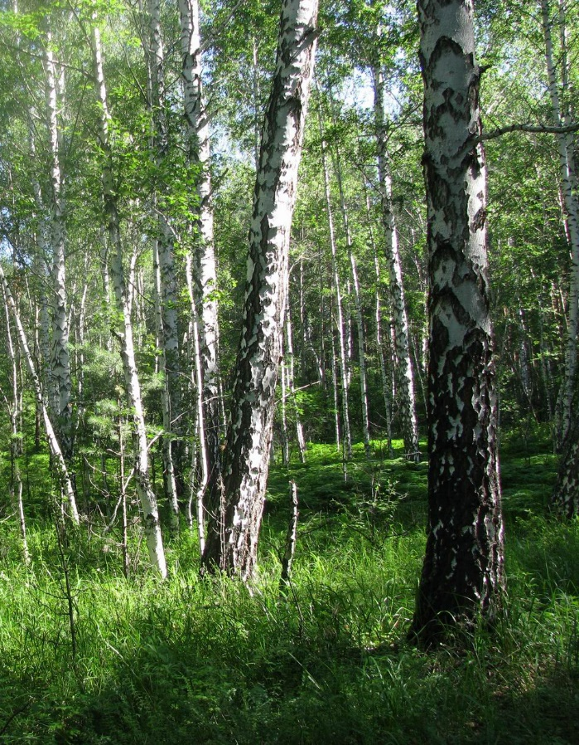 | 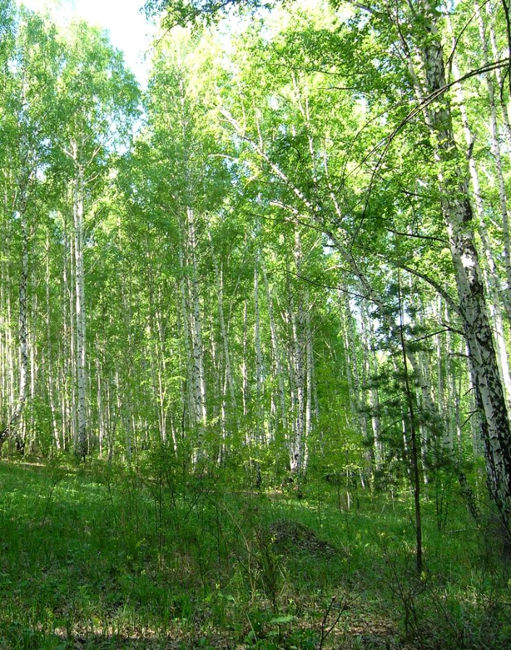
C | D
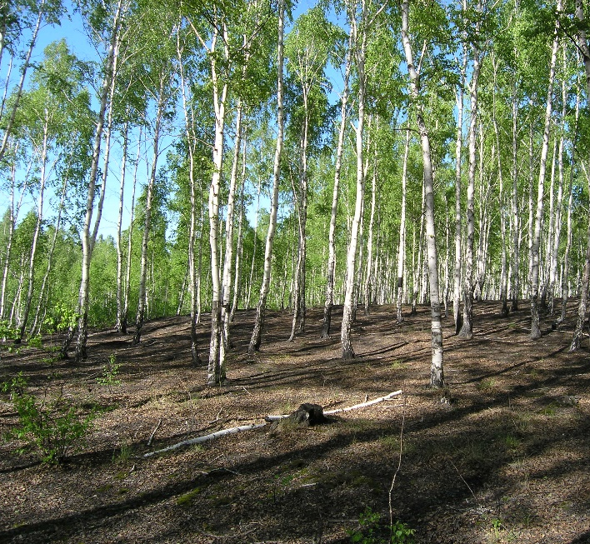 | 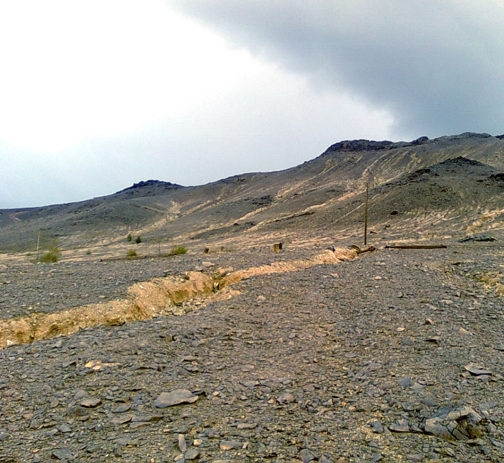
Fig. S1. Vegetation structure at the study sites in the pollution gradient by emissions of the Karabash Copper Smelter: (A) site 26S, undamaged forest, background zone; (B) site 11N, moderately damaged forest, buffer zone; (C) site 4S, severely damaged forest, impact zone; (D) site 1E, industrial barren.

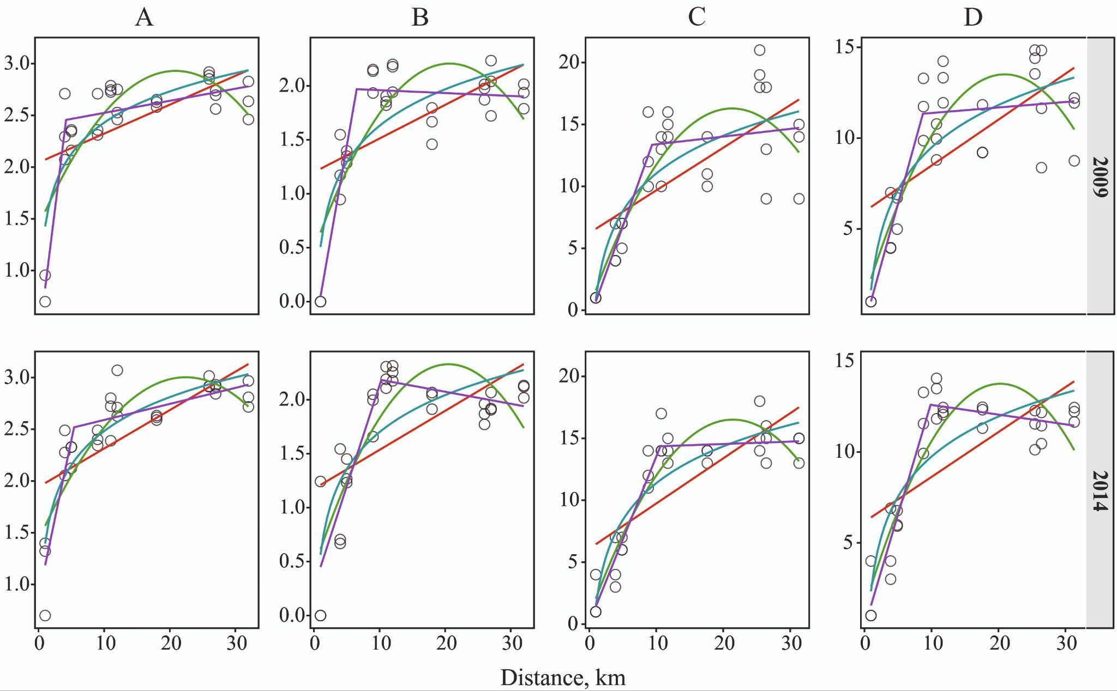
Fig. S2. Models of dependence of abundance, log10 individuals per 10 traps-day (A), diversity, Shannon index (B), species richness observed (C) and interpolated per 100 individuals (D) of ground beetles on the distance to the Karabash copper smelter: red—linear, purple—segmented (piecewise linear), green—polynomial, blue—logarithmic

Table S3. Akaike's criterion for models of dependence of abundance, species richness and diversity on distance to the Karabash copper smelter
Models | Index
Models | abundance,  Log₁₀ | Observed species richness | Interpolated species richness | Shannon index
2009 г.
linear segmented | -12.18 | 148.18 | 123.36 | -9.26
polynomial | 21.57 | 151.72 | 132.49 | 26.02
logarithmic | 14.62 | 155.00 | 134.87 | 21.3
linear | 36.24 | 167.65 | 151.28 | 42.92
2014 г.
linear segmented | -7.45 | 109.51 | 94.53 | 9.25
polynomial | 13.7 | 129.03 | 125.67 | 28.34
logarithmic | 0.37 | 138.15 | 133.00 | 30.69
linear | 31.04 | 161.67 | 157.97 | 49.37

Table S4. Ecological traits of dominant species of ground beetles, compiled from literary data (1-5) and expert assessment (6)
Species | Ecological trait
Species | Body size | Stratum preference | Habitat preference | Feeding preferences | Mobility | Source
Amara brunnea (Gyll.) | S | LS | F | Mx | hm | 1, 5
Amara communis (Panz.) | S | LSV | E | Mx | hm | 1, 2, 3, 5
Bembidion lampros (Hbst.) * | S | LS | Oh | Z | mm | 1, 3, 5
Calathus micropterus (Duft) | S | LS | F | Z | lm | 2, 3, 5
Carabus cancellatus Ill. | L | SS | E | Z | lm | 2, 3, 5
C. granulatus L. | L | SS | E | Z | mm | 3, 4, 5
Harpalus affinis (Schrank) * | M | LSV | Oh | Mx | hm | 2, 3, 5
Harpalus smaragdinus (Duft.) * | M | LSV | Oh | Mx | hm | 3, 5
Microlestes minutulus (Gz.) * | S | SS | Oh | Z | hm | 3, 5
Poecilus versicolor (Sturm) | M | LS | Oh | Z | mm | 1, 2, 5
Pterostichus magus (Mnnh.) | L | LS | F | Z | lm | 6
P. mannerheimi (Dej.) | L | LS | F | Z | lm | 5, 6
P. melanarius (Ill.) | L | LS | E | Z | mm | 3, 4, 5

Continuation of the table S4
P. niger (Schal.) | L | LS | E | Z | mm | 3, 5
P. oblongopunctatus (F.) | M | LS | F | Z | mm | 1, 2, 3, 5
P. uralensis (Motsch.) | M | LS | F | Z | lm | 5, 6
Synuchus vivalis (Ill.) | S | LS | Oh | Z | mm | 2, 3, 5

Note: * species found in the industrial barren; S—small-size individuals: 3–9 mm; M – middle-size individuals: 9.1–11 mm; L – large-size individuals: >11 mm; LS—forest litter, humus horizon of soil; SS—soil surface; LSV—forest litter, humus horizon of soil and vegetation; F—forest; E—eurytopic; Oh—open habitats (meadow-field and coastal meadow); Z—zoophages, Mx—mixo-phytophages; lm—low mobility, mm—moderate mobility, hm—high mobility.

References
- Boer P.J., 1990. The survival value of dispersal in terrestrial arthropods. Biol. Conserv. 54, 175-192.
- Hendrickx F., Maelfait J-P, Desender K., Aviron S., Bailey D., Diekotter T., Lens L., Liira J., Schweiger O., Speelmans M., Vandomme V., Bugter R., 2009. Pervasive effects of dispersal limitation on within- and among-community species richness in agricultural landscapes. Global Ecol. Biogeogr. 18 (5), 607–616.
- Klaiber J., Altermatt F., Birrer S. et al., 2017. Fauna Indicativa. WSL Berichte. 54.
- Matalin K.V., 2003.Variations in flight ability with sex and age in ground beetles (Coleoptera, Carabidae) of south-western Moldova. Pedobiologia. 47(4), 311–319.
- Voronin A.G., 1999. Fauna and complexes of ground beetles (Coleoptera, Trachypachidae, Carabidae) of the forest zone of the middle Urals (ecological and zoogeographical analysis). Perm State University Publishing, Perm [in Russian]
- Matalin K.V., personal message

